Тренировочные варианты ЕГЭ по разделу «Говорение» 2017
Variant 1
Task 1. Imagine that you are preparing a project with your friend. You have found some interesting material for the presentation and you want to read this text to your friend. You have 1.5 minutes to read the text silently, then be ready to read it out aloud. You will not have more than 1.5 minutes to read it.
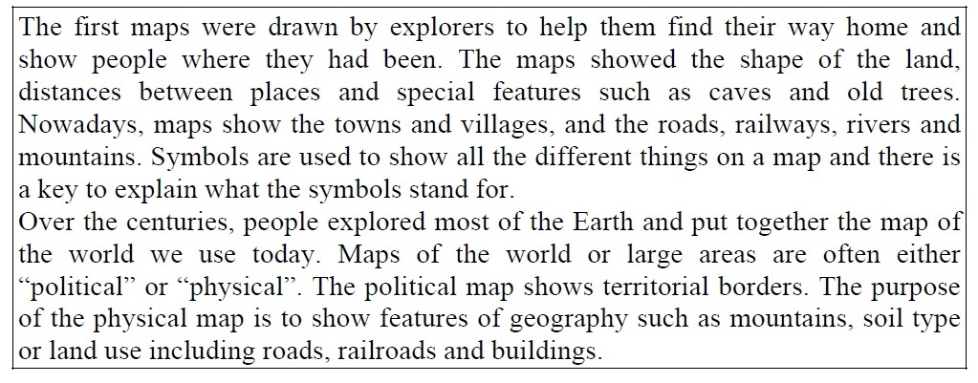

Task 2. Study the advertisement.
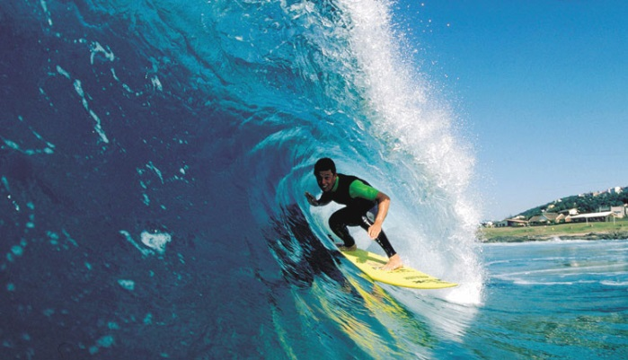
You are taking a language course in Australia. You want to try surfing. You have just found an advertisement to join a local surfing club. You are calling to the club to make some clarifications. In 1.5 minutes you are to ask five direct questions to find out about the following:
- location of the club
- classes for beginners available
- availability of personal coach
- price per week
- discounts for students
You have 20 seconds to ask each question.

Task 3. These are photos from your photo album. Choose one photo to describe to your friend.
You will have to start speaking in 1.5 minutes and will speak for not more than 2 minutes (12–15 sentences).
In your talk remember to speak about:
- where and when the photo was taken
- what/ who is in the photo
- what is happening
- why you keep the photo in your album
- why you decided to show the picture to your friend
You have to talk continuously, starting with:
I’ve chosen photo number ….
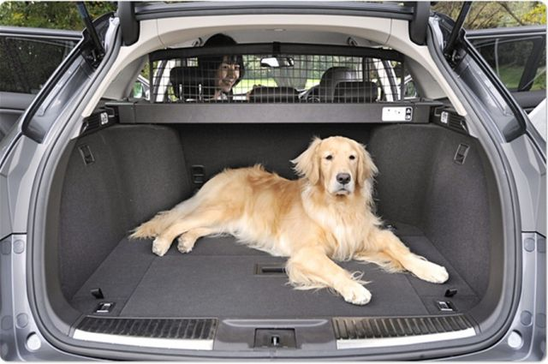 | 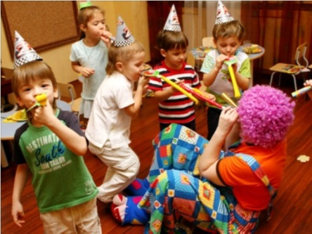

Task 4. Study the two photographs. In 1.5 minutes be ready to compare and contrast the photographs:
- give a brief description of the photos (action, location)
- say what the pictures have in common
- say in what way the pictures are different
- say what kind of ski you would prefer
- explain why
You will speak for not more than 2 minutes. You have to talk continuously.
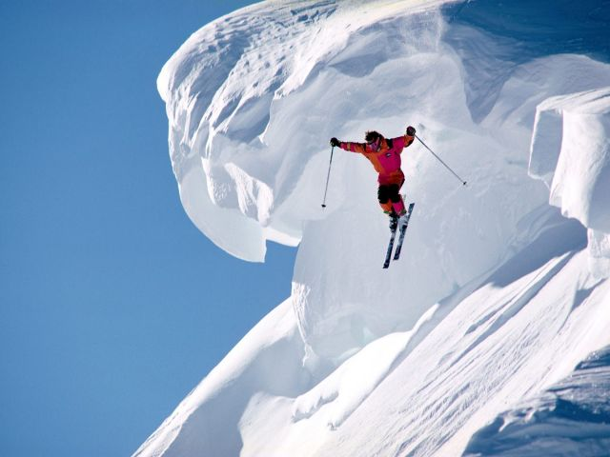 | 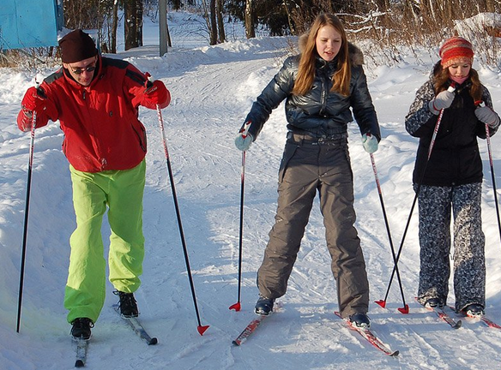

Variant 2
Task 1. Imagine that you are preparing a project with your friend. You have found some interesting material for the presentation and you want to read this text to your friend. You have 1.5 minutes to read the text silently, then be ready to read it out aloud. You will not have more than 1.5 minutes to read it.
Task 2. Study the advertisement.
You and your family are going to spend 2 weeks in Cyprus. You have just found an advertisement about a nice hotel. You are making a phone call to the hotel to make some clarifications. In 1.5 minutes you are to ask five direct questions to find out about the following:
- location
- rooms for a family of 4 available
- distance from the hotel to the sea
- price for 2 weeks
- discounts for small kids under 3
You have 20 seconds to ask each question.

Task 3. These are photos from your photo album. Choose one photo to describe to your friend.
You will have to start speaking in 1.5 minutes and will speak for not more than 2 minutes (12–15 sentences).
In your talk remember to speak about:
- where and when the photo was taken
- what/ who is in the photo
- what is happening
- why you keep the photo in your album
- why you decided to show the picture to your friend
You have to talk continuously, starting with:
I’ve chosen photo number ….
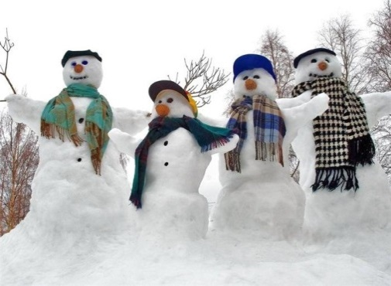

Task 4. Study the two photographs. In 1.5 minutes be ready to compare and contrast the photographs:
- give a brief description of the photos (action, location)
- say what the pictures have in common
- say in what way the pictures are different
- say what kind of shopping you would prefer
- explain why
You will speak for not more than 2 minutes. You have to talk continuously.
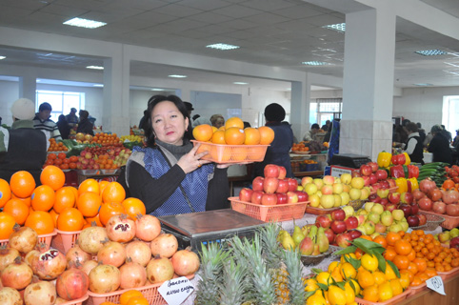

Variant 3
Task 1. Imagine that you are preparing a project with your friend. You have found some interesting material for the presentation and you want to read this text to your friend. You have 1.5 minutes to read the text silently, then be ready to read it out aloud. You will not have more than 1.5 minutes to read it.
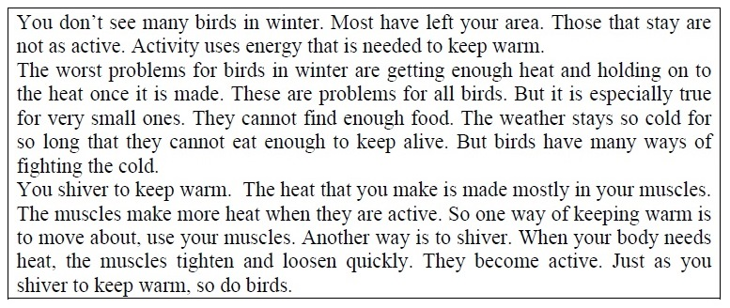

Task 2. Study the advertisement.
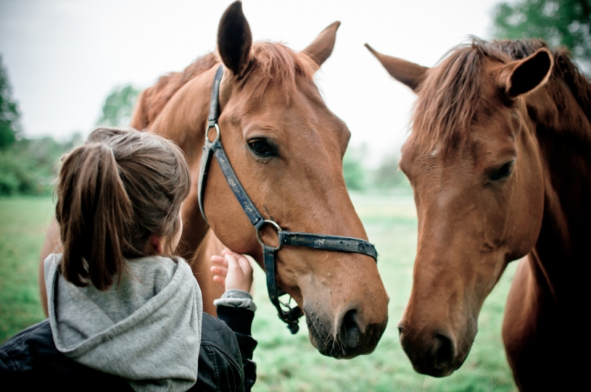
You are taking a language course in England. You want to try horse-riding. You have just found an advertisement to join a local horse-riding club. You are calling to the club to make some clarifications. In 1.5 minutes you are to ask five direct questions to find out about the following:
- location
- timetable
- personal coach available
- price for a 10 days-course
- discounts for students
You have 20 seconds to ask each question.

Task 3. These are photos from your photo album. Choose one photo to describe to your friend.
You will have to start speaking in 1.5 minutes and will speak for not more than 2 minutes (12–15 sentences).
In your talk remember to speak about:
- where and when the photo was taken
- what/ who is in the photo
- what is happening
- why you keep the photo in your album
- why you decided to show the picture to your friend
You have to talk continuously, starting with:
I’ve chosen photo number ….
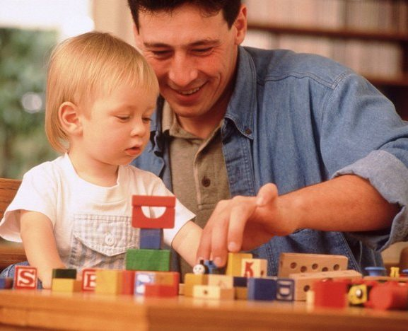

Task 4. Study the two photographs. In 1.5 minutes be ready to compare and contrast the photographs:
- give a brief description of the photos (action, location)
- say what the pictures have in common
- say in what way the pictures are different
- say what kind of telephone you would prefer
- explain why
You will speak for not more than 2 minutes. You have to talk continuously.
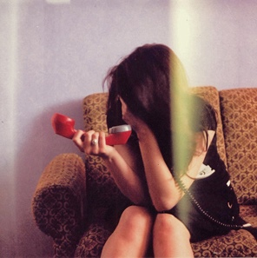

Variant 4
Task 1. Imagine that you are preparing a project with your friend. You have found some interesting material for the presentation and you want to read this text to your friend. You have 1.5 minutes to read the text silently, then be ready to read it out aloud. You will not have more than 1.5 minutes to read it.
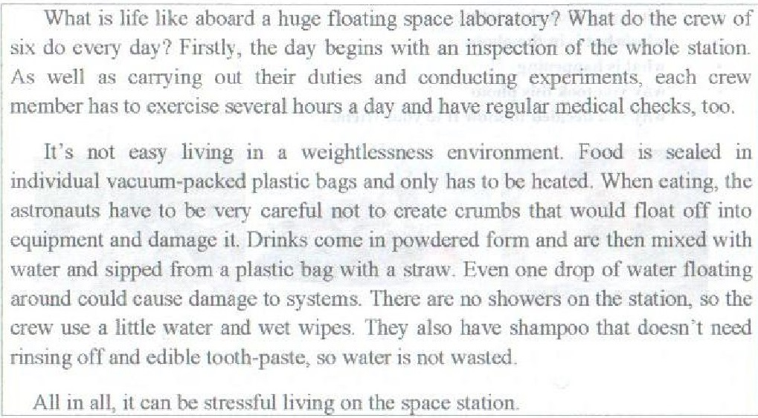
Task 2. Study the advertisement.
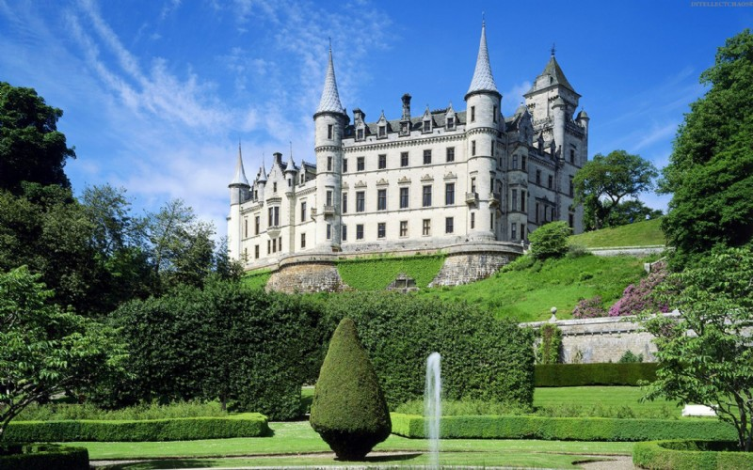
You are taking a language course in Scotland. You want to visit an ancient castle with a group of Russian friends. You are calling to the club to make some clarifications. In 1.5 minutes you are to ask five direct questions to find out about the following:
- opening hours
- excursion for today available
- Russian speaking guide available
- ticket price
- discounts for a group
You have 20 seconds to ask each question.

Task 3. These are photos from your photo album. Choose one photo to describe to your friend.
You will have to start speaking in 1.5 minutes and will speak for not more than 2 minutes (12–15 sentences).
In your talk remember to speak about:
- where and when the photo was taken
- what/ who is in the photo
- what is happening
- why you keep the photo in your album
- why you decided to show the picture to your friend
You have to talk continuously, starting with:
I’ve chosen photo number ….
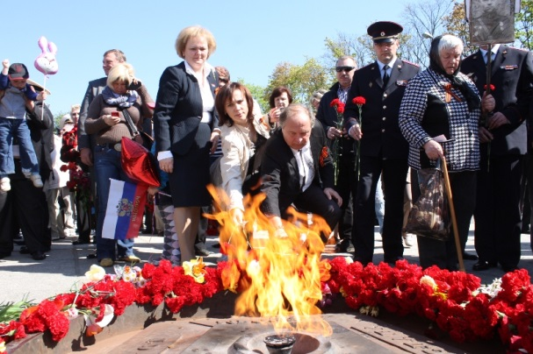

Task 4. Study the two photographs. In 1.5 minutes be ready to compare and contrast the photographs:
- give a brief description of the photos (action, location)
- say what the pictures have in common
- say in what way the pictures are different
- say what kind of music you would prefer to listen to: classical or rock
- explain why
You will speak for not more than 2 minutes. You have to talk continuously.
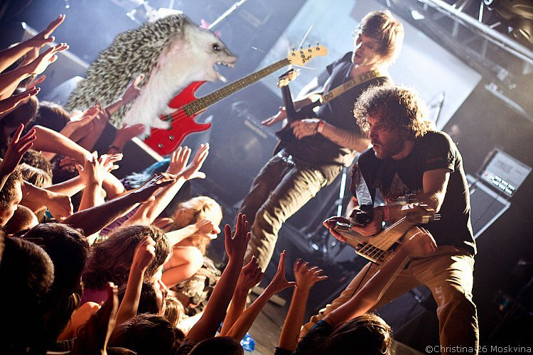 | 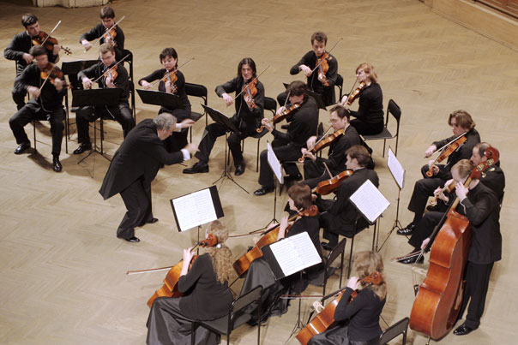

Variant 5
Task 1. Imagine that you are preparing a project with your friend. You have found some interesting material for the presentation and you want to read this text to your friend. You have 1.5 minutes to read the text silently, then be ready to read it out aloud. You will not have more than 1.5 minutes to read it.
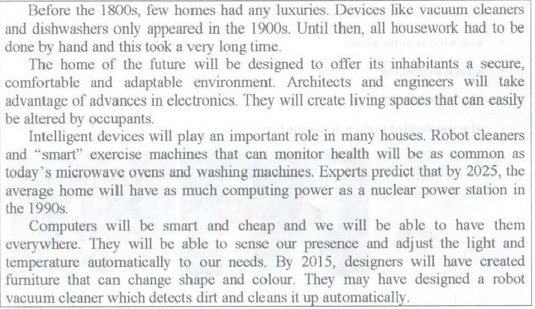
Task 2. Study the advertisement.
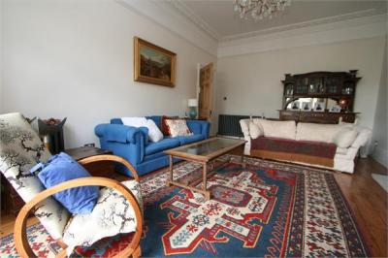
You are doing to stay in London with the group of students next month. You want to reserve some rooms. You are making a phone call to the reception to make some clarifications. In 1.5 minutes you are to ask five direct questions to find out about the following:
- location
- availability of double rooms
- facilities offered
- price for a 5 nights for double room
- discounts for a group of students
You have 20 seconds to ask each question.
Task 3. These are photos from your photo album. Choose one photo to describe to your friend.
You will have to start speaking in 1.5 minutes and will speak for not more than 2 minutes (12–15 sentences).
In your talk remember to speak about:
- where and when the photo was taken
- what/ who is in the photo
- what is happening
- why you keep the photo in your album
- why you decided to show the picture to your friend
You have to talk continuously, starting with:
I’ve chosen photo number ….

Task 4. Study the two photographs. In 1.5 minutes be ready to compare and contrast the photographs:
- give a brief description of the photos (action, location)
- say what the pictures have in common
- say in what way the pictures are different
- say what kind of books: paper or electronic books you would prefer to read
- explain why
You will speak for not more than 2 minutes. You have to talk continuously.
Variant 6
Task 1. Imagine that you are preparing a project with your friend. You have found some interesting material for the presentation and you want to read this text to your friend. You have 1.5 minutes to read the text silently, then be ready to read it out aloud. You will not have more than 1.5 minutes to read it.
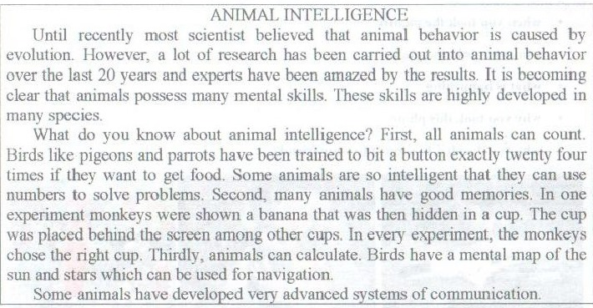
Task 2. Study the advertisement.
You are going to the cinema. You want to reserve a ticket. You are making a phone call to the booking office to make some clarifications. In 1.5 minutes you are to ask five direct questions to find out about the following:
- films on
- session start time
- tickets available
- ticket price
- discounts for students
You have 20 seconds to ask each question.
Task 3. These are photos from your photo album. Choose one photo to describe to your friend.
You will have to start speaking in 1.5 minutes and will speak for not more than 2 minutes (12–15 sentences).
In your talk remember to speak about:
- where and when the photo was taken
- what/ who is in the photo
- what is happening
- why you keep the photo in your album
- why you decided to show the picture to your friend
You have to talk continuously, starting with:
I’ve chosen photo number ….
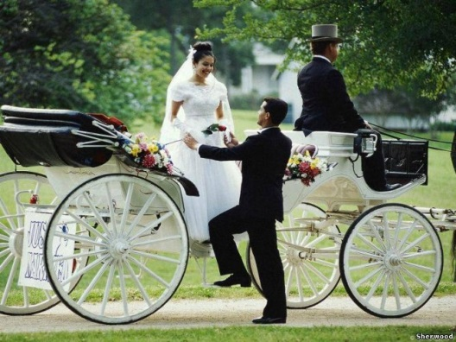

Task 4. Study the two photographs. In 1.5 minutes be ready to compare and contrast the photographs:
- give a brief description of the photos (action, location)
- say what the pictures have in common
- say in what way the pictures are different
- say how you celebrate holidays, what kind of festivals you prefer
- explain why
You will speak for not more than 2 minutes. You have to talk continuously.
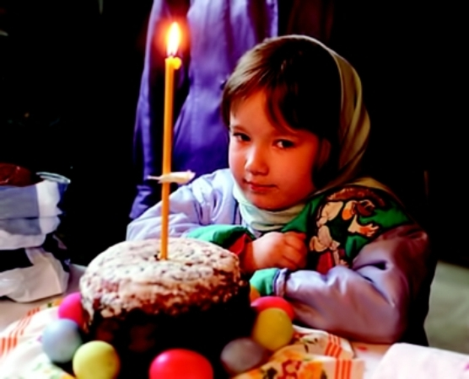

Variant 7
Task 1. Imagine that you are preparing a project with your friend. You have found some interesting material for the presentation and you want to read this text to your friend. You have 1.5 minutes to read the text silently, then be ready to read it out aloud. You will not have more than 1.5 minutes to read it.
Task 2. Study the advertisement.
You would like to buy a ticket for Saturday performance. You need a seat in the stalls. You are making a call to the theatre box-office to make some clarifications. In 1.5 minutes you are to ask five direct questions to find out about the following:
- Saturday performances
- tickets available
- time of performance
- ticket price
- discounts for students
You have 20 seconds to ask each question.
Task 3. These are photos from your photo album. Choose one photo to describe to your friend.
You will have to start speaking in 1.5 minutes and will speak for not more than 2 minutes (12–15 sentences).
In your talk remember to speak about:
- where and when the photo was taken
- what/ who is in the photo
- what is happening
- why you keep the photo in your album
- why you decided to show the picture to your friend
You have to talk continuously, starting with:
I’ve chosen photo number ….
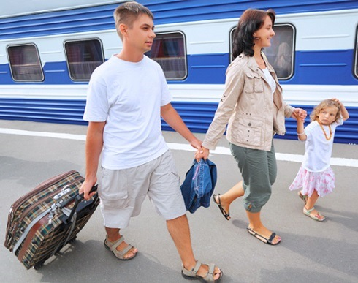 | 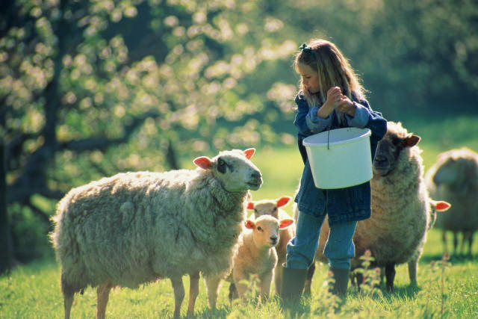 | 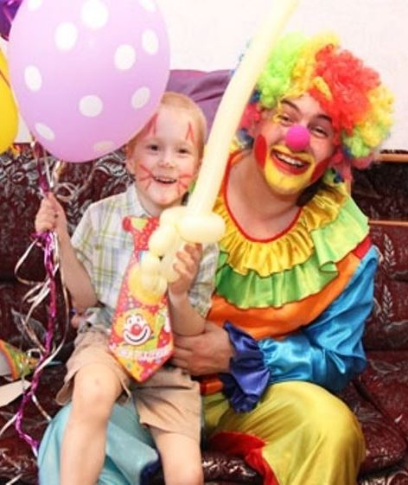

Task 4. Study the two photographs. In 1.5 minutes be ready to compare and contrast the photographs:
- give a brief description of the photos (action, location)
- say what the pictures have in common
- say in what way the pictures are different
- say what kind of restaurants you would prefer to eat out
- explain why
You will speak for not more than 2 minutes. You have to talk continuously.

Variant 8
Task 1. Imagine that you are preparing a project with your friend. You have found some interesting material for the presentation and you want to read this text to your friend. You have 1.5 minutes to read the text silently, then be ready to read it out aloud. You will not have more than 1.5 minutes to read it.
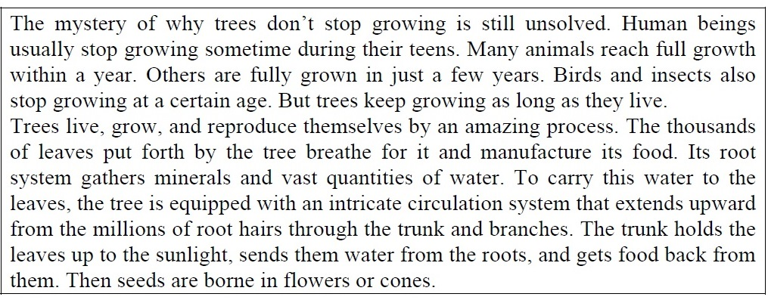

Task 2. Study the advertisement.
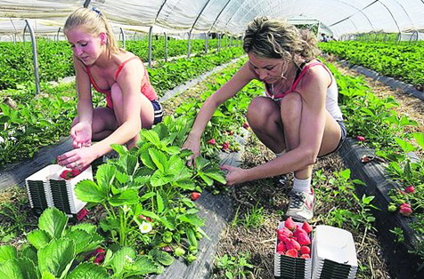
You would like to apply for a summer job. You are making a call to the job centre to make some clarifications. In 1.5 minutes you are to ask five direct questions to find out about the following:
- availability of jobs
- job descriptions
- skills required
- working hours
- payment
You have 20 seconds to ask each question.

Task 3. These are photos from your photo album. Choose one photo to describe to your friend.
You will have to start speaking in 1.5 minutes and will speak for not more than 2 minutes (12–15 sentences).
In your talk remember to speak about:
- where and when the photo was taken
- what/ who is in the photo
- what is happening
- why you keep the photo in your album
- why you decided to show the picture to your friend
You have to talk continuously, starting with:
I’ve chosen photo number ….
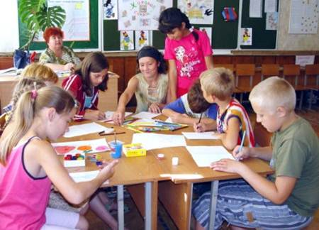 |  | 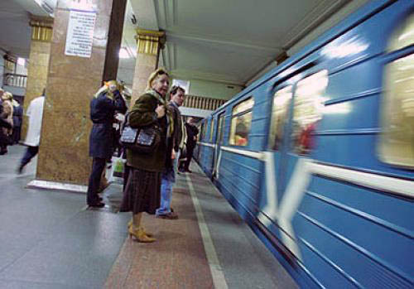

Task 4. Study the two photographs. In 1.5 minutes be ready to compare and contrast the photographs:
- give a brief description of the photos (action, location)
- say what the pictures have in common
- say in what way the pictures are different
- say what means of travelling you would prefer
- explain why
You will speak for not more than 2 minutes. You have to talk continuously.
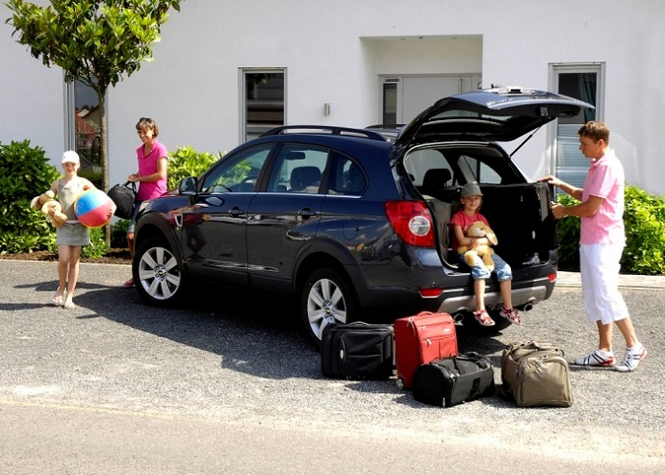

Variant 9
Task 1. Imagine that you are preparing a project with your friend. You have found some interesting material for the presentation and you want to read this text to your friend. You have 1.5 minutes to read the text silently, then be ready to read it out aloud. You will not have more than 1.5 minutes to read it.
Task 2. Study the advertisement.
You are having your birthday and you would like to reserve a table for Saturday night. You are making a call to the restaurant to make some clarifications. In 1.5 minutes you are to ask five direct questions to find out about the following:
- tables available
- live music
- types of cuisine available
- discounts for students
- special offer
You have 20 seconds to ask each question.
Task 3. These are photos from your photo album. Choose one photo to describe to your friend.
You will have to start speaking in 1.5 minutes and will speak for not more than 2 minutes (12–15 sentences).
In your talk remember to speak about:
- where and when the photo was taken
- what/ who is in the photo
- what is happening
- why you keep the photo in your album
- why you decided to show the picture to your friend
You have to talk continuously, starting with:
I’ve chosen photo number ….
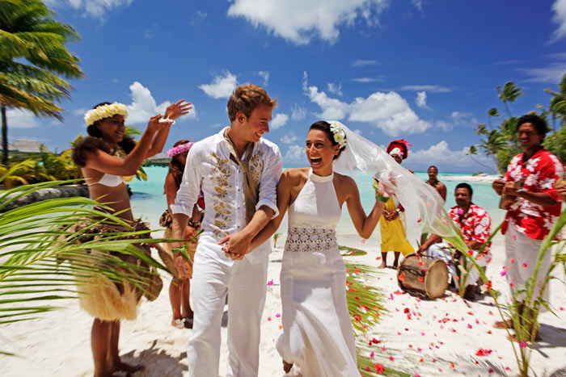

Task 4. Study the two photographs. In 1.5 minutes be ready to compare and contrast the photographs:
- give a brief description of the photos (action, location)
- say what the pictures have in common
- say in what way the pictures are different
- say what kind of travelling (travelling by plane of by train) you would prefer
- explain why
You will speak for not more than 2 minutes. You have to talk continuously.
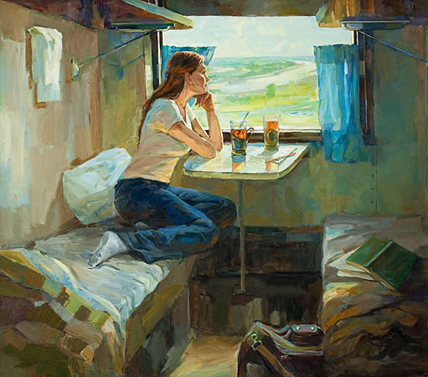

Variant 10
Task 1. Imagine that you are preparing a project with your friend. You have found some interesting material for the presentation and you want to read this text to your friend. You have 1.5 minutes to read the text silently, then be ready to read it out aloud. You will not have more than 1.5 minutes to read it.
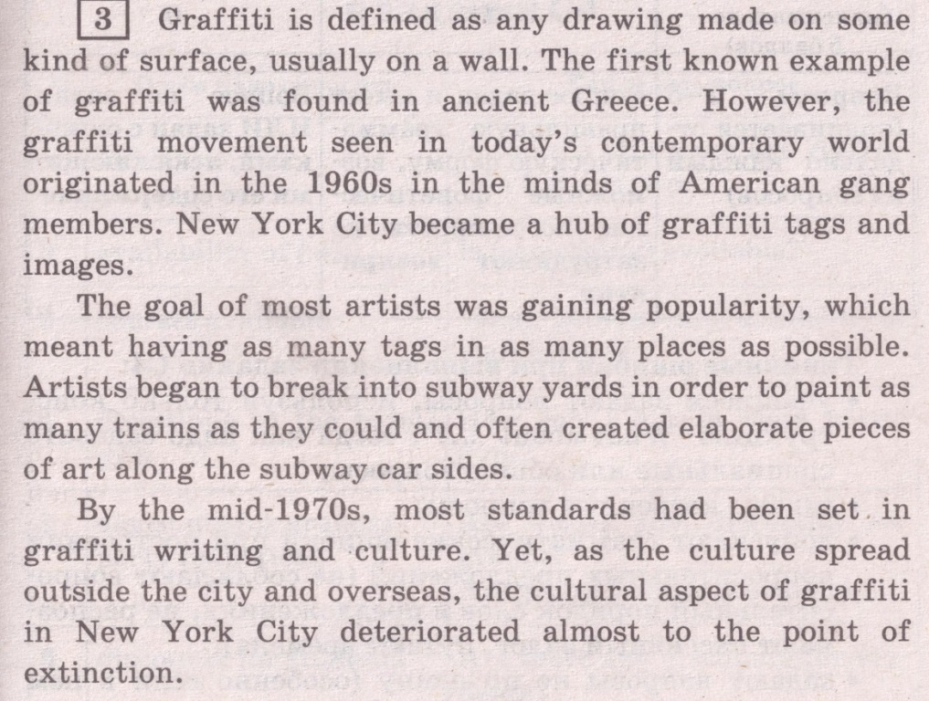
Task 2. Study the advertisement.
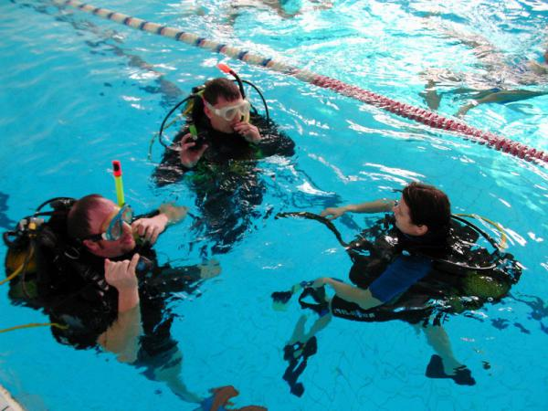
You are going to study abroad for three months and would like to go in for diving. You are calling to make some clarifications. In 1.5 minutes you are to ask five direct questions to find out about the following:
- location
- price for beginner course
- duration of the course
- necessary gear
- discounts for students
You have 20 seconds to ask each question.
Task 3. These are photos from your photo album. Choose one photo to describe to your friend.
You will have to start speaking in 1.5 minutes and will speak for not more than 2 minutes (12–15 sentences).
In your talk remember to speak about:
- where and when the photo was taken
- what/ who is in the photo
- what is happening
- why you keep the photo in your album
- why you decided to show the picture to your friend
You have to talk continuously, starting with:
I’ve chosen photo number ….
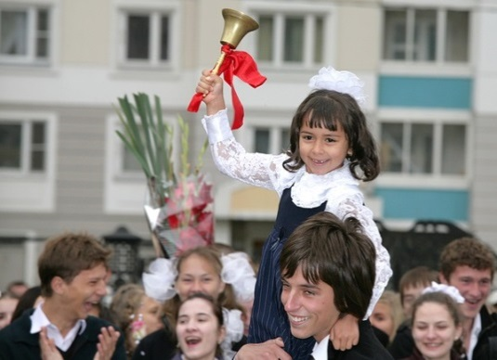 |  | 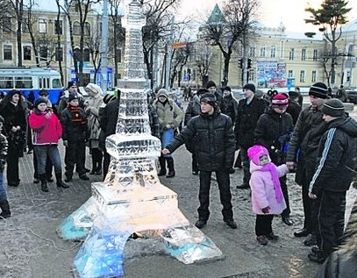

Task 4. Study the two photographs. In 1.5 minutes be ready to compare and contrast the photographs:
- give a brief description of the photos (action, location)
- say what the pictures have in common
- say in what way the pictures are different
- say which of the pets presented in the pictures you’d prefer
- explain why
You will speak for not more than 2 minutes. You have to talk continuously.
